Name: Felix Asibor
ID: VEPH/20B/DA204
Task 52A: Investigative Analytical Process with SQL (Short Report)

Report Summary on Murder Mystery Police Investigation

Investigative Process Followed
The investigation followed a structured path to identify the perpetrator of the crime using SQL queries on the provided relational database. The process was carried out in stages to mirror a real-life detective workflow:

1. Initial Case Review
- Began with the given crime scene description: a murder that occurred on January 15, 2018, in the city of SQL City.
- Established the initial parameters: date, location, and type of crime.

2. Crime Scene Analysis
- Identified and retrieved details of two key witnesses from the crime scene report:
- Morty Schapiro – lived at the last house on Northwestern Dr.
- Annabel Miller – lived on Franklin Ave.

3. Witness Identification & Statements
- Queried the database to confirm witness details.
- Extracted and analyzed their interview logs for leads.

4. Suspect Identification
- From Morty’s statement, filtered suspects by gym membership ID starting with 48Z and Gold membership.
- Narrowed down to Joe Germuska and Jeremy Bowers.
- Annabel’s statement confirmed both were at the gym on January 9, 2018.

5. Vehicle Evidence Cross-Check
- Morty’s additional statement revealed a vehicle plate containing H42W.
- Cross-referenced DMV records, finding two possible owners.
- Verified Jeremy Bowers matched both gym and vehicle evidence.

6. Prime Suspect Pinpointed
Confirmed Jeremy Bowers as the murderer using combined evidence (witnesses + gym membership + vehicle records).

7. Mastermind Investigation
- Jeremy’s confession hinted at a mastermind.
- Queried personal records and attendance logs for suspects.
- Checked SQL Symphony concert records (attendance 3 times in December).
- Identified Miranda Priestly as the mastermind behind the murder.

Queries Executed and Their Purpose

1. Crime Scene Report Table
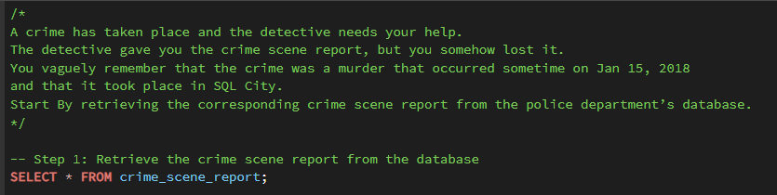
Purpose: To retrieve the crime scene report from the Police Investigation Database
Output
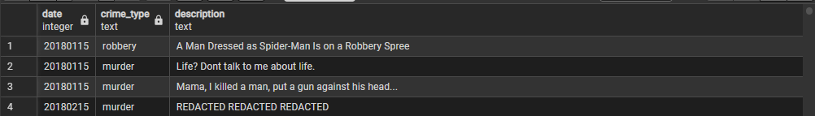
Explanation: This shows the crime scene report table with details of what happened

2. Crime Scene Report Based on Information Provided
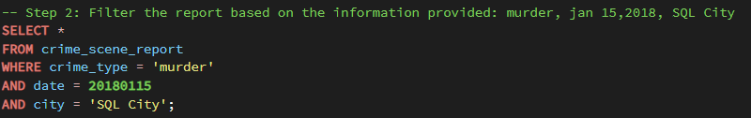
Purpose: To retrieve the initial case details and witness information.
Output
Explanation: The crime scene report tells of two witnesses with various descriptions. The first witness lives at the last house on Northwestern Dr. While the second witness’ name is Annabel who lives somewhere on Franklin Ave.

3a. First Witness Identification
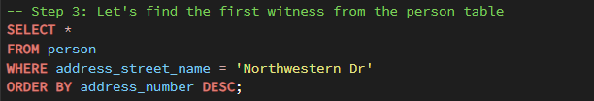
Purpose: Find the first witness living at the address mentioned in the crime scene report.
Output
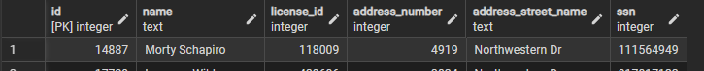
Explanation: These are the details of the first witness

3b. Second Witness Identification
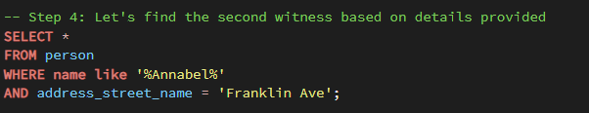
Purpose: Find the second witness living at the address mentioned in the crime scene report and name mentioned.
Output
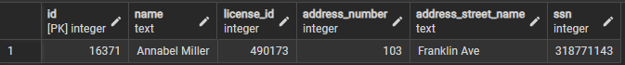
Explanation: This is the details of the second witness based on the information provided.
The Key witnesses are Morty Schapiro and Annabel Miller. The next step is to review their interview logs to get their statement and further dig into the investigation to uncover the murder suspect.
4. Get Witnesses Statements
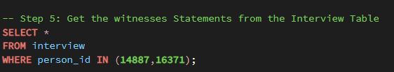
Explanation: This query filters the interview table based on the person_id of the two witnesses at the crime scene.
Output
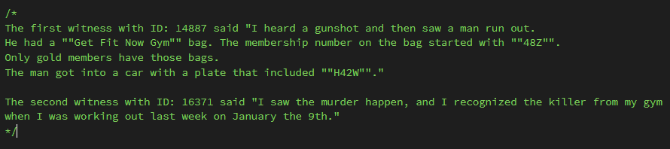

5. Use the First Witness Statement to Find the Suspect
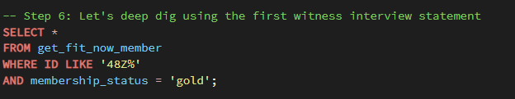
Explanation: Using the statement from the first witness, I ran this query using brief details they provided to try to locate the murder suspect. The LIKE keyword here is used to search for the pattern that starts with 48Z… The output result will return results that start with 48Z and membership status that is gold.
Output
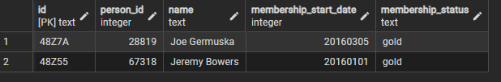
Explanation: Based on the query above, we found two gold members with 48Z ID. Their names are Joe Germuska and Jeremy Bowers.
6. Review the Second Witness Statement
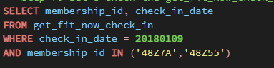
Explanation: Based on what the second witness said, we’re using the where keyword to filter the date the witness visited the gym and also checking which of the suspects did visit as well. It turns out that both suspects visited the gym on that same date
Output
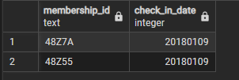
I’ve been able to review both witnesses’ statements and I discovered that the killer was a member of the Get Fit Now Gym Member who checked in on the 9th of January 2018.
Now, we want to further dig into the investigation by reviewing again, what the first witness said.
7. Review First Witness Additional Statement
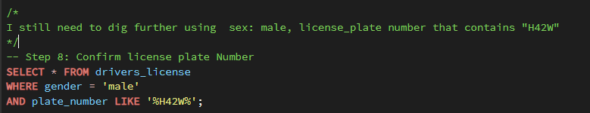
Explanation: The first witness also said the he saw a man get into a vehicle with plate number that contain ‘H42W’. So, I ran the query and we have the result below.
Output
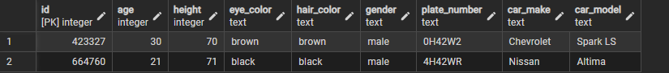
Explanation: We have two men with similar plate number and we can verify their license_id from the person’s table.

8. Verify the License ID to Find Who Owns the Car
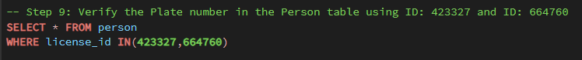
Explanation: I used the ID I got from the previous query to pinpoint the car owners. Right now, we have found two persons with similar plate number, but one of them rings a bell.
Output
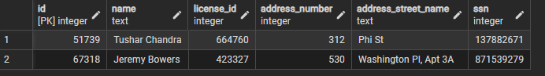
9. Pinpoint the Actual Killer
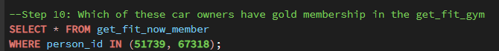
Explanation: We have to verify which of these guys have gold membership at the gym
Output

We can see that Jeremy Bowers is the Murder suspect for this investigation.
10. Review Jeremy’s Statement
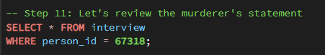
Explanation: Using the person_id, I queried the interview table to find the suspect’s statement.
Output
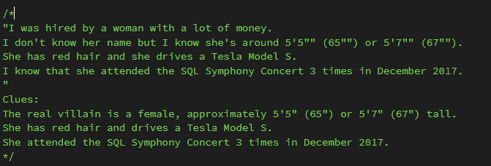
This is what Jeremy said. We now have some cues about the mastermind behind this murder
11. Use the Clues Provided to Find the Mastermind
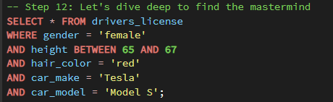
Output
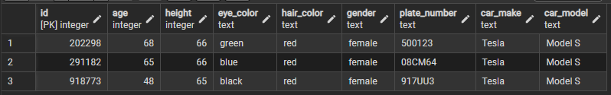
Based on the query above, we have three potential masterminds. The next thing we want to do is to get their personal details and check for the one that attended SQL Symphony Concert three times.

12. Get their Personal Details
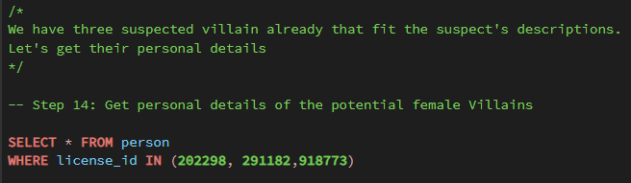
Explanation: We use the person table to identify the potential mastermind using their license id
Output
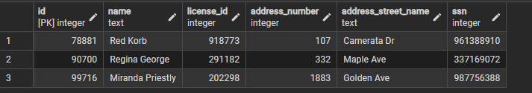
We have three potential suspects with their personal details on display. Next, we want to check which one of them attended the SQL symphony 3x in December
13. Verify SQL Symphony Attendance
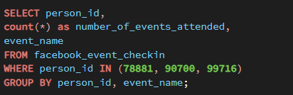
Explanation: Using their ID, I verified which of the female mastermind attended the SQL symphony three times.

Output
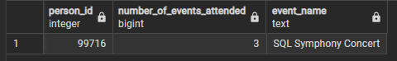
So, we have just one ID here. So, who does this ID belong to?
14. Verify the Mastermind
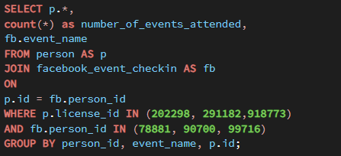
Explanation: Using the inner join, I combined two queries to simply filter the mastermind behind the murder
Output
So based on the query above, we have Miranda Priestly as the mastermind behind the murder committed by Jeremy Bowers

Key Findings
1. Witnesses Identified
- Two witnesses, Morty Schapiro and Annabel Miller, were crucial in guiding the investigation.
- Their statements provided leads about the suspect’s ID pattern (48Z), gym membership status, and car license plate.

2. Prime Suspect Confirmed
Using gym records, license plate data, and membership verification, Jeremy Bowers was identified as the murderer. His gold membership and vehicle records matched both witnesses’ descriptions.
3. Mastermind Revealed
- Jeremy’s confession pointed to a mastermind behind the crime.
- Cross-checking personal details and event attendance revealed Miranda Priestly as the orchestrator.
- Attendance records of the SQL Symphony (3x in December) confirmed her identity.
4. Methodical SQL Queries
The structured use of SQL across multiple tables (crime scene, witness interviews, memberships, vehicle records, event attendance) mirrored real-world investigative workflows. Each stage narrowed the pool of suspects systematically.

Recommendations
1. Database Integration for Law Enforcement
Establish linked relational databases (crime reports, DMV, gym memberships, event records) to speed up cross-referencing in real investigations.
2. Witness Management System
Implement a digital tracking system for witness statements and link them with case databases to prevent oversight and ensure quick retrieval.
3. Event Attendance Surveillance
High-profile events should maintain secure attendance logs (digital check-ins, ID verification) to aid future investigations.

4. Advanced Query Templates
Law enforcement agencies could benefit from pre-built SQL query templates for crime scene analysis, suspect verification, and cross-database searches.
5. Follow-up Investigations
- Further probe Miranda Priestley’s network to uncover possible accomplices.
- Review Jeremy Bowers’ background and ties to the mastermind for broader criminal links.

